Woori Wallabies Playgroup
Term 3, 2019

Starting Back Tuesday 23rd July
Tuesday’s 1:30-3:00pm in the Multi-purpose Room

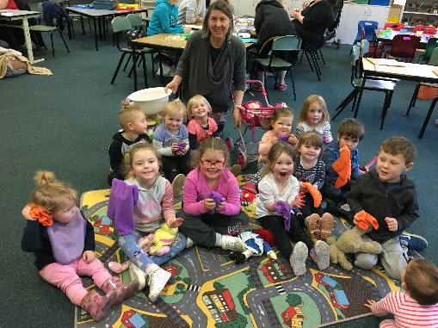
Welcome everyone, our starting time is at 1.30pm, but please don't be put off coming if you can't get here in time - just come when you can! This term we will look at a number of themes starting with the season-Winter through to mini beasts. We also have 3 Prep transition days and if you know anyone with a pre-school child they are most welcome to come along. Our ever-popular Judy from Eastern Region’s Yarra Junction Library will come along to share and read new release and we will continue to offer arts and craft activities too.

Don’t forget to sign in!
There are information flyers about all the above in the resource area, as well as other handouts which you might find useful. We also have a limited number of DVDs entitled "Raising Children" and "Let's Read" which you are welcome to have.

We welcome parents to sit and join in with our activities and share in the fun and the pleasure of experiencing our playgroup. Remember, Veronica and myself can help support you with any parenting worries.

During the last week of term, the school production called The Wizard of Oz is taking place, and Playgroup families will be most welcome to come along and see the show. I will need an expression of interest from families to come to our Matinee on Tuesday the 10th of Sept (time to be confirmed). Our last session for the term will be the previous week, on the 3rd September.

We welcome parents to sit and join in with our activities and share in the fun and the pleasure of experiencing our playgroup. Remember, Veronica, Carol and myself can help support you with any parenting worries.
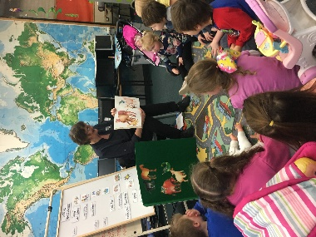
Playgroup Dates & Themes
23rd July- Winter
30th July- Mini beasts
6th Aug- Books (Eastern Library Story Time visit)
13th Aug-Pets
20th Aug-Circus
27th Aug-Father’s Day
3rd Sept-Superheros (last session for the term)
10thSept School Production Matinee performance-The Wizard of Oz
We encourage parents and carers to sit with their children during the song and story time as children love sharing this time with the adults in their lives. Please feel free to sing along and do the actions with them! Also, remember to borrow and swap books from our library corner.

Andre & Veronica

