Woori Wallabies Playgroup Attendance Record Term 3, 2017
Please sign in each week as you arrive
Parent Name | Children | DOB | Allergies | Wk 2  25/7  Prep transition | Wk 3  1/8 | Wk 4  8/8  Lib visit | Wk 5  15/8 | Wk 6  22/8 | Wk 7  29/8 | Wk 8  5/9 | Wk 9  12/9 | Wk 10  19/9  Production
Donna Stent | Ishaan | 28/6/13 | Eggs
Cassie Darwall | Max  Oscar | 22/5/12  8/11/13 | -  -
Cloe Tormey | Charlotte | 20/6/13 | -
Kellie Sajo | Noah | 1/5/12 | Asthmatic
Rebecca Roda | Evie  Frankie | 30/12/13 | -
Gay Hillas | Sonny | 17/6/14 | -
Renee Nebel | Kurtis | 20/8/13 | Epilepsy
Dani Ahmad | Jacob | 18/5/12 | -
Belinda Ottley | Rose  Theo | 9/7/13  12/4/15
Tania Hallett | Jai | 29/6/2014 | -
Jenny | Aleyah  Alec  Tianna | 12/7/15  27/9/13  6/5/12 | -
Jullian Schaak | Dixi | 21/7/14 | -
Allisa Lucas | Troy | 13/08/15 | -
Parent Name | Children | DOB | Allergies | Wk 2  25/7  Prep transition | Wk 3  1/8 | Wk 4  8/8  Lib visit | Wk 5  15/8 | Wk 6  22/8 | Wk 7  29/8 | Wk 8  5/9 | Wk 9  12/9 | Wk 10  19/9  Production
Sharina Pereira | Abigail  Havannah | 22/5/13  9/12/16 | -  -
Sally Pratt | Evelyn | 18/5/15 | Lactose
Crystal Keating | Casey | 26/5/15 | -
Kim Jordan | Willow Layla | 15/12/14  11/10/12 | -
Sarah Revatsos | Harlie | 8/5/13 | -
Jacinta van Eijk | Brodie | 5/11/14 | -
Nicole Thorneycroft | Jackson | 10/9/2012 | -

Themes-Term 3 2017
Date  Theme | Craft | Book | CD Music | Songs | Activity | Items
25th July  Mini beasts  Prep transition | 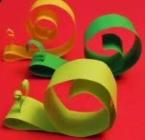  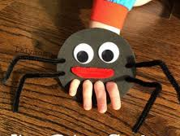  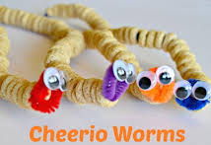  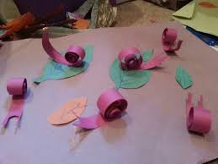 | The Very Hungry Caterpillar | Actions-Hop like a cricket, flap like a butterfly, buzz like a bee, crawl like worm | Wash our Hands  Itsy Bitsy Spider  Little Miss Muffet  The Ants Go Marching  Goodbye song | Painting  Colouring  Play dough  Afternoon tea/fruit  Outside play/bikes | Painted caterpillars  Lady bug biscuits marie biscuits/  Spider web activity
1st Aug  Winter | 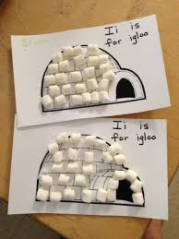  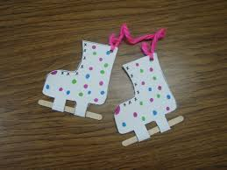  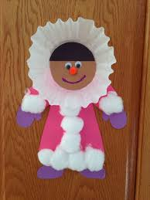 |  |  | I can see a Rainbow | Outside play | Paper plates,  Coloured paper  String
8th Aug  Prep transition | Story Time!  Eastern Library | Books about me!  Book marks | Yarra Junction Library new releases | Monster song | Wash our Hands  1,2,3,4,5 once I caught a fish alive.  Goodbye song | Colouring  Play dough  Hand traced chook face  Paper plate chook  Afternoon tea/fruit
15th Aug | Cooking-  Dinosaur fossils  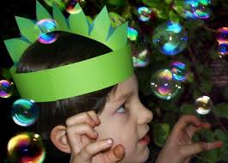  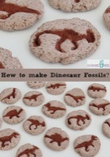 | The Lost Dinosaur |  | Wash our Hands  Dingle Dangle Scarecrow  Goodbye song | Colouring  Play dough  Afternoon tea/fruit  Outside play/bikes | Cookie dough  Icing  Food colouring
22nd Aug  Africa | 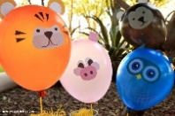  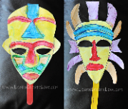  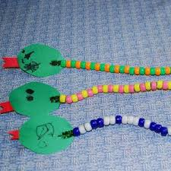 | Put me in the Zoo  Cranky Crocodile | Walking Through the jungle | Wash our Hands  5 Little Ducks  Old Mac Donald Had a Zoo  Goodbye song | Colouring  Afternoon tea/fruit  Musical Instruments  Outside play/bikes | Pipe cleaners  Paper plates  Cardboard  markers
29th Aug | Father’s Day  Kinder transition  placemat  photo/hand print  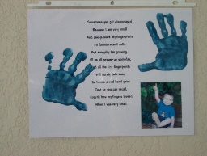 |  |  |  |  | Photos, coloured card, markers, poem. Laminating pouches, googly eyes, craft glue.
5th Sept  Superheros | 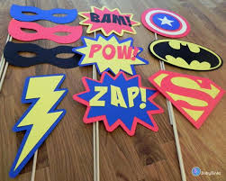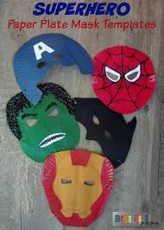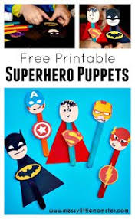 |  | Wash our Hands  Peter & Paul finger song  Goodbye song  Borrowed books from library | Colouring  Playdough  Parachute game | Potatoes, pipe cleaners, googly eyes, craft glue, coloured paper, hat elastic, cardboard/masks | Superheros
12th Sept  Spring | 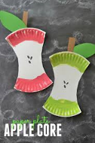  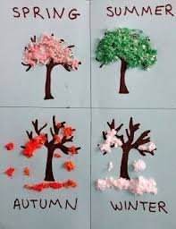  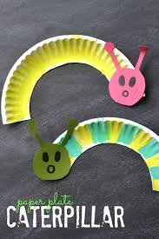  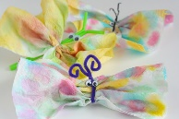
19 ^{th} Sept | Whole School Production- matinee
